第七次实验报告

**学号：**202030310117 **姓名：**王宏身  **班级：**自2003

代码

#include<iostream>

using namespace std;

class Complex {

double real;

double imag;

public:

Complex(double r = 0.0, double i = 0.0);

void print();

Complex operator+(Complex c);

};

Complex::Complex(double r, double i)

{

real = r; imag = i;

}

Complex Complex::operator+(Complex c)

{

Complex temp;

temp.real = real*c.real-imag*c.imag;

temp.imag = real*c.imag+c.real*imag;

return temp;

}

void Complex::print()

{

cout << "total real=" << real << " " << " total imag=" << imag << endl;

}

int main()

{

double x1, x2, y1, y2;

cin >> x1 >> y1 >> x2 >> y2;

Complex com1(x1, y1), com2(x2, y2), total1;

total1 = com1 + com2;

total1.print();

return 0;

}

结果

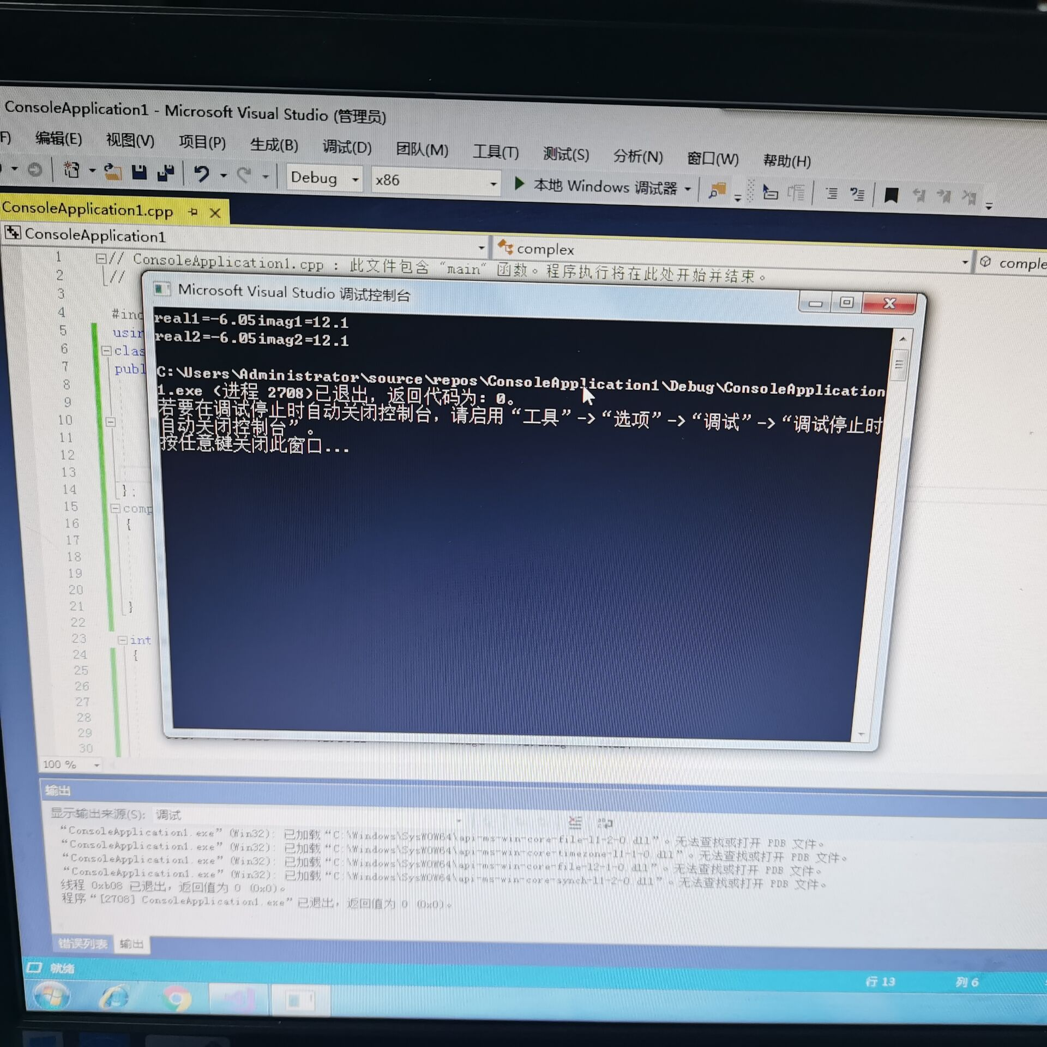

心得

本次上机实验为最后一次上机实验，总体来说，运算符重载实际上是类的一个补充，本次实验相比于之前几次要轻松一点，复数的乘法相比于加法而言仅仅是算法有所改变，但我们更应该进行实践，由此对运算符重载有更深入的理解。

Copyright ©2021-2099 HongshenWang. All rights reserved